+ **Manual testing**

1. **What is Software testing?**

Testing is a part of software development process and it activate to detect and identify the defects like errors, bugs and gaps

It is objective of testing to deliver quality product to client.

1. **What is Software quality?**

Quality is defined as justification all the requirements of a customers in a product and quality is not define the product . it is defined in customer mind and it is design within the client budget only.

Quality software like bug-fee, Deliver on time, meets requirement, budget.

1. **What are difference between product and project?**

**Project:** Project is nothing but software application it is design for specific customer based on requirement then it is called Project.

**Ex:** Physical , Desigtal.

**Product:** Product is nothing but Software Application it is design multiple customers based on market requirement then it called product.

**Ex:** E-commerce, Mobile App

1. **Why do we need testing?**

software testing is play main role in software development and first detect the errors and fix it then after remove errors .it will improve quality .

for examples like error, defect, failure…

**Error :** human do in correct action in system it will make problem in system is called error.

**Defect/bug:** it means deviation from expected behavior to actual behavior of system like Functional Defects, Performance Defects, Security Defects

**Failure:** the deviation identify by end user while using the system like Test Case Failure**, Functional Failure, Integration Failure.**

1. **Why the software has bugs normally.**

* Miscommunication or no communication.
* Software complexity.
* Programming errors.
* Changing requirement.
* Lack of skilled testers.
* Human errors.
* Poor communication.

1. **What is software Development Life Cycle (SDLC)?**

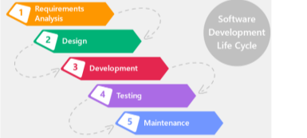

1. **What is waterfall model (Advantages &Disadvantages)?**

**Advantages**

* Quality of product will be good.
* Initial test are good.
* Preferred the small projects where required are feezed.
* Easy to Manage.
* Early System Design.
* Well-Defined Testing Phase.

**Disadvantages**

* Late Testing.
* Limited Customer Feedback.
* Requirement changes are not allowed.
* Testing will be start after coding.

1. **Why testing is necessary?**

If any level of testing cannot declare that there is no defect in the product

**Why is it required at all?**

that whatever they have developed is as per customer requirements and will always work. But, it is

imperative to create real-life scenario and undertake actual execution of a product at each level of software building

**Developers may have excellent skills of coding but integration issues:**

* can be present when different units do not work together, even though they work independently

One must bring individual units together and make the final product, as some defects may be

possible when the sources are developed by people sitting at different places.

**The primary role Of software testing is not to demonstrate the correctness of**

* software product, but to expose hidden defects so that they can be fixed.
* Testing is done to protect the common users from any failure of system during usage.

**Testing is a process Of demonstrating that errors are not present in the product:**

This approach is used in acceptance testing where if the application meets acceptance criteria then it must be accepted by the customer.

* Testing gives number of detects present which indirectly gives a measurement of software quality.
* More number of defects Vindicate bad software and bad processes Of development

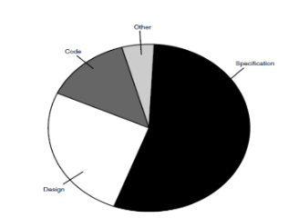

**Types of testing**

1. **Manual testing :** Manual testing is process of detecting defect ,errors with out using automated tools.

2. **Automation testing :** Automation testing means will write scripts and uses another software to test the product. This process involves automation of manual process. Automation testing is used to re-run test scenarios the perform the manually quickly repeatedly.

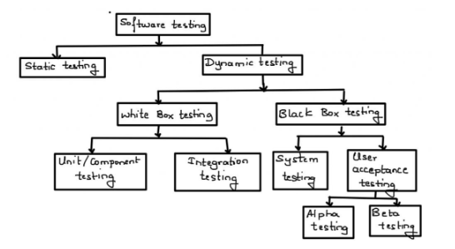

**1.Static testing :**.

**Review:** Reviews involve examining documents, code, or other defects manually or collaboratively to find errors and improvements.

**Types of reviews:**

**1. walk through reviews**

* It not a formal process.
* It is led of the authors.

**2. Informal review**

* Unplanned and undocumented

**3. Technical review**

* It is define the default detection process.
* Documented.

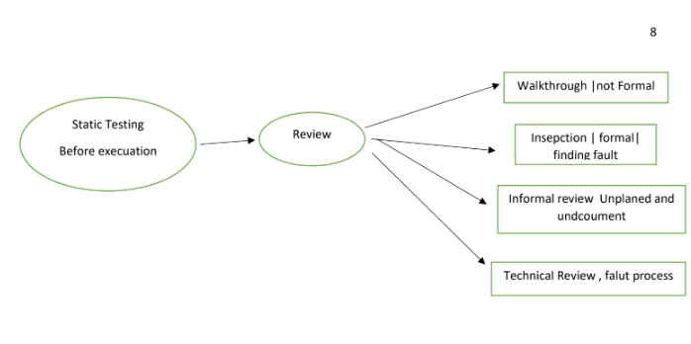

**Dynamic testing techniques**

Dynamic testing means it is a runtime testing and it will excuted test cases on runtime.

**Level of testing**

**1.Unit testing:** In unit testing individual of software testing and the main purpose of testing to check the each module.it will focus of smallest unit in software testing.

Ex: It will check loops, methods or functions.

**2.Integration testing:** combined the individual units and tested as group like.

* Top-down.
* Bottom-Up.
* Sandwich
* Big-Bang

**3.System Testing:** In testing we can test whole application done by tester.

**4.acceptance testing:** it is level of testing which software test.

* **Alpha testing:** done by tester in company presence of customer.
* **Beta testing:** done by customer to check software is ok.

**Types of testing**

**Functional testing:** it use the black box testing tester has knowledge internal system logic. functional testing only concerned with validating if a System works as intende and it will compare the actual and expected output.

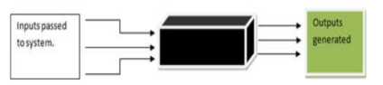

**There are difference types of functional testing**

1. **Non-Functional testing**

* Load testing
* Reliability
* The redness of system
* Usability Testing

1. **Black box testing**

Black box testing is testing you do not source code, just the executable code in hands and test will done without internal knowledge of the product.

1. **White box testing**

It is low level testing.

White box testing is called **glass box testing, clear box testing** or **structural testing and white box testing that test internal structure rather then it will apply the unit ,integration and system level process. white box testing use tools like CppUnit, Nunit, Rcunit etc.**

1. **Smoke testing:**

**It is process of to check the condition it is stable or not.**

1. **Sanity Testing:**

**Sanity testing to verify the specific functionality work correctly to fix bugs.**

**What are difference between smoke testing and sanity testing.**

**Smoke testing :** only compulsory feature testing on new build.

**Sanity testing :** check the compulsory and optional because it is stable.

**Some of the most popular models in SDLC are:**

* **Waterfall model.**
* **V-Shape model.**
* **Incremental life cycle model.**
* **Spiral model**.

**Waterfall model:** it is old version.

It linear model it is step by step executed.

Initial investment less because no tester are involved

**V-Shape model:** verification and validation.

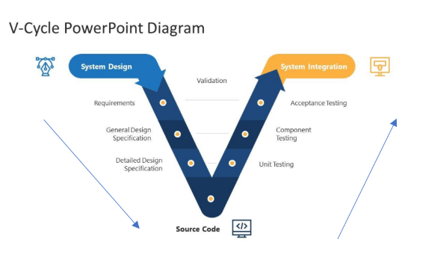

**Spiral model:** Spiral model is iterative model.

Spiral Model does overcome drawbacks of water fall.

Spiral model follows the dependency on the module and every software released new software for customer.

Spiral software will released multiple version so it is also call version controller.

**What are difference between advantage and disadvantages of spiral model.**

**Advantage of spiral:**

* Testing is done in every cycle before going to next cycle.
* Customer will get to use the software for every model.
* Requirement changes are allowed before go to next life cycle.

**Disadvantages:**

* Requirement changes are not allowed between the cycle.
* Every cycle of spiral model looks like waterfall model.
* There is no testing requirement and design phases.

**Increment model:**

The requirement are divided int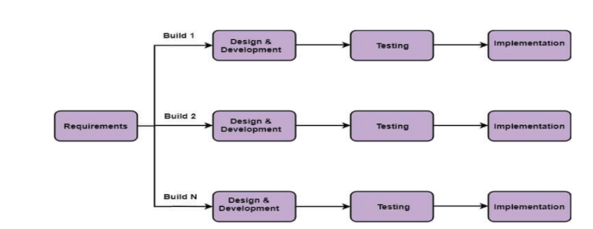o multiple model like analysis, design coding, testing, maintenance.

**System Testing**

1. **GUI Testing**

Testing GUI application , user interface testing

such as menus , check boxes , icon, images

not functional , just look and feel

1. **Usability testing**

* check the easiness of application
* helping messages are display if user confuse
* check user friendly application or not

1. **Functional**

* Check behavior of application
* Check database testing**.**

1. **Non functional testing.**

It have different testing are there software testing , performance testing, Application testing.

**End-point testing**

**Endpoint testing** is a type of software testing focused on verifying the functionality, reliability, security, and performance of an application's **endpoints.**

**Test case design technique:**

It helps better design and reduce the number of test case to be executed Reduce data and more coverage.

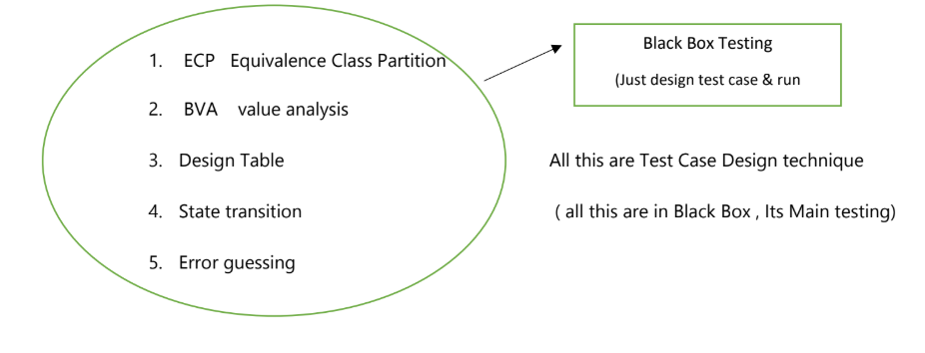

**ECP → Equivalence Class Partition**

* value check
* partition data in → multiple classes to save testing time.

**Error Guessing Technique:**

No specific rule.

It is based on the skill of testing.

**Test case Scenario:** simply the name of test what to test

**Test case document:** Test case Id, Test case Title, Description Precondition, Priority, Request id, Action, Excepted result, Actual result, Test Data.

**RTM(Requirement Traceblity matrix):**

* Trace how many Test case are executed .
* In simple keep track of test cases.

**What is difference between the testing and Debugging?**

**Testing:** Testing is done by finding the errors.

**Debugging:**  Debugging is an part of fixing the bugges.

**Black Box testing:** Mainly perform by testers.

**White box testing:** Mainly perform by developers.

**Unit testing:** Part of White box testing.

**Acceptance testing:** This is the final testing done by Customer based on the agreements Load.

**Usability testing:** Testing to determine the user friendly ness of the application.

**Install / Uninstall testing:** Testing of full, partial, or upgrade install / uninstall processes.

**Recovery / failover testing:** Testing to determine how well a system recovers from crashes, failures,

or other major problems.

**Incremental integration testing:** Continuous testing of an application as new functionality is added

**Ad-hoc testing:** Conducting testing without requirements

**Comparison testing:** Comparing software weaknesses and strengths to competing products.

**Alpha testing:** Part of UAT.

**Beta testing:** Part of UAT.

**Integration testing:** validating combined modules of an application

**Functional testing:** part of black box testing

**System testing:** part of black box testing and validating the system requirements

**End to End testing:** similar to system testing

**Sanity testing or smoke testing:** An initial validation of a new build or release

**Regression testing:** validating the existing functionality of the application once new fixes added

**Compatibility testing:** Testing an application in different environments.

**What is test case?**

The test case is document It will define the pre-condition , post condition, test data, action, navigation of particular functionality test case should have unique style like Id and name.

**What is Test Plan?**

Test Plan is a document that explains what to test, when to test, where to test and when to complete

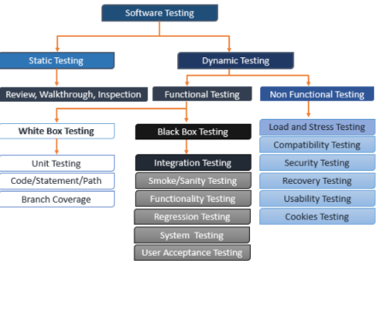

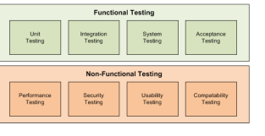

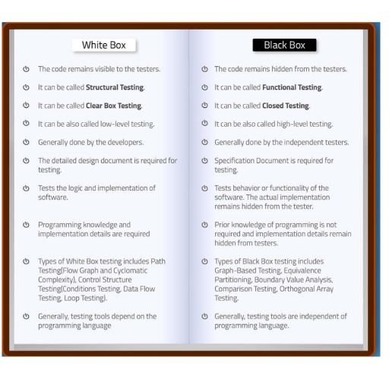

**What are advantages and disadvantages of whit box testing?**

**Advantages:** white box optimizes code so hidden error can be identified.

Test cases of white box testing can be easily automated.

This testing is more through than other testing approaches as it covers all code paths.

It can be started in sdcl phases even without GUI.

**Disadvantages:** white box testing is too much consuming.

White box testing mush expensive and complex.

It can lead production error because it is not by the developer.

**There are two main categories of testing**

**1.Static testing:**

* Static testing is completed without executing the program.
* This testing is executed in verification stage.
* Static testing is executed before the compilation.
* The cost is less for finding the defects and fixes.
* It consists of Walkthrough, Inspection, reviews etc.

**2.Dynamic testing.**

* Dynamic testing is completed with the execution of program.
* This testing is executed in validation stage.
* Dynamic testing is executed after the compilation.
* This testing finds and fixes the defects.
* It consists of unit testing, integration testing etc.

**Software testing:**

Software testing terminologies like Error, Defects, bug, failure ,Missing and wrongs, Faults.

**What is verification?**

It is static process analyzing of document not actual product.

**What is validation?**

It is involes dynamic testing like unit testing, integration testing ,System testing.

**What are difference between verification and validation?**

**Verification**: it is verify the intermediate products like design document, ER diagram, test plain and traceability matrix

* Developer point of view
* Verify without executing the software code.

**Validation**: validate the final product like software developer or service or system.

* Customer point view.
* Validated by software executing code.
* Techniques used: functional testing, system testing ,Smoke testing.

**What is difference between functional and non-functional?**

**Functional testing:** functional testing based on client requirement.

* Functional testing test application against business requirement.
* It is part of System testing.
* Functional testing validating the behavior of application.
* Functional testing covers the unit testing, integration testing, smoke testing, sanity testing ,regression testing .
* It is always concentrating customer requirement

**Non-functional testing:** functional testing is based on client expectation

* Non-functional testing means the test application against and performance requirement.
* It is part of system testing.
* Non functional testing is validating the performance of application.
* It always concentrating the customer expectation.

**What are difference between smoke testing and sanity testing?**

**Smoke testing:** Smoke testing performed by the both developers testers.

Smoke test build by the either stable or unstable.

It is done initial builds.

It is part of basic testing.

It is done by every time there is new build released.

**Sanity testing:** Sanity testing performed by testers alone.

Sanity testing build relatively stable.

It is part of regression testing.

It is planned when there is no enough time to do in depth testing.

**Exploratory testing:** we have to explore the application, understand

Completely test.

* Understand the application, understand scenarios, document use for test.
* Testing engineer will do exploratory testing when there is no requirement.

**Drawbacks:** you might misunderstanding any feature as bug.

* Time consuming.
* If there is bug in application you never know about.

**Adhoc testing:** Test application randomly without any test case.

Adhoc testing is informal testing types with an aim to break the system.

This testing id unplanned testing.

**Monkey/Gorilla testing**

Test application randomly without any test case.

Adhoc testing is informal testing types with an aim to break the system.

Tester do not have knowledge.

Suitable for the gaming applications.

**What are difference between Monkey, Adhoc testing, Exploratory testing.**

2. What is difference between the static testing and dynamic testing?

**Static testing:**

* Static testing was done by the before execution of program .
* It is done the verification process
* It about prevention of defects.
* It static testing cost of finding defects and fixing is less.

**Dynamic testing:**

* Dynamic testing is done by execution the program.
* It does the validation process.
* It is about finding and fixing the defects.
* It is performed alter compilation.
* In dynamic testing cost of finding and fixing defects is high.